FE CSEAIML (Div A and B)
Basic Electrical and Electronics Engineering (ESC 102) AY 2025-26
Practice questions unit 1

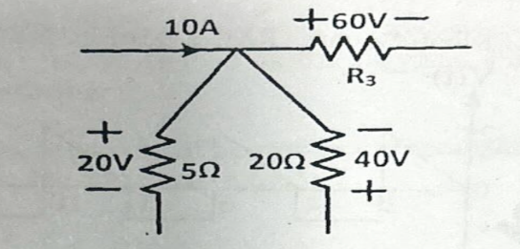
1. Define KVL. Find value of R3 in the figure given below by applying Kirchhoff's laws.

2. Find current in 5 ohm by nodal analysis.

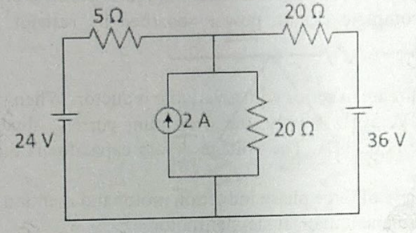

3. Find equivalent resistance between A & B in the network shown.

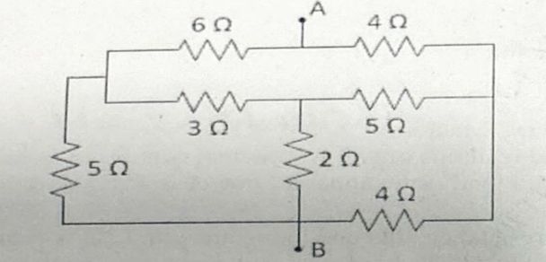

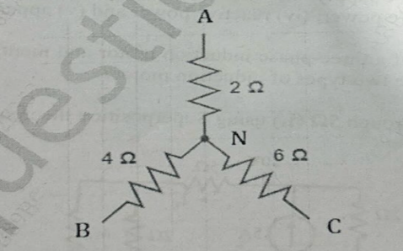
4. Draw the equivalent delta network. Mention the formula used for the conversion.

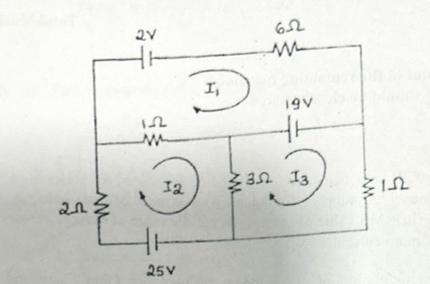
5. Find the currents I1, I2, I3 and the current through 32 using mesh analysis?

6. Give the steps for mesh analysis with example. Find current through 3 Ω resistor by mesh analysis.
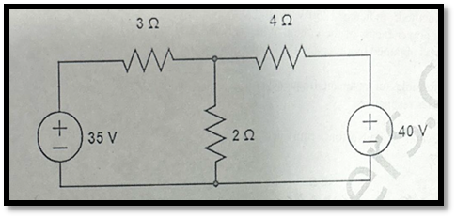
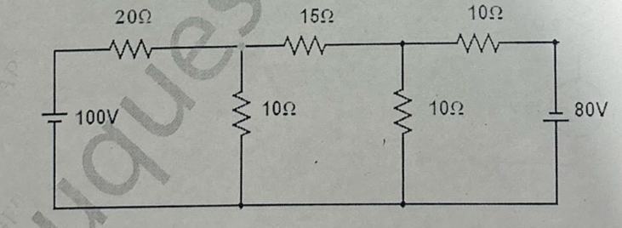
7. Find the current through 15 ohm through nodal
analysis?

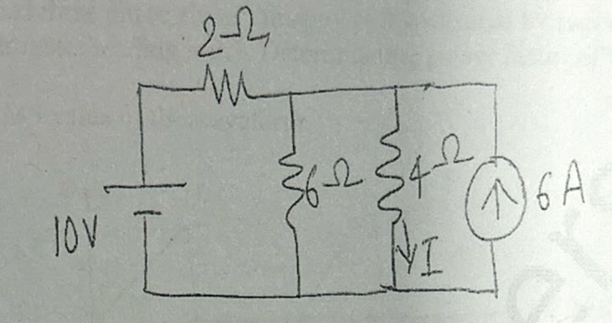
8. Using source transformation, find I in the circuit shown.

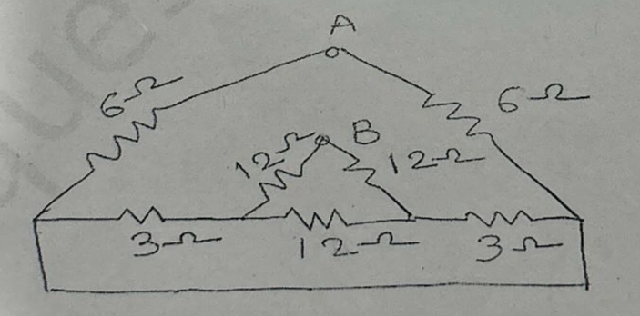
9. Find the equivalent resistance between A&B.

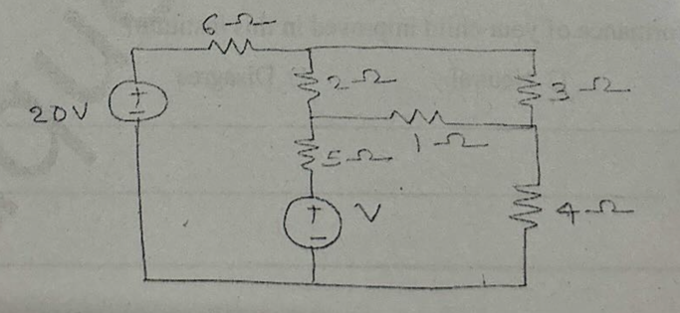
10. By mesh analysis, find V.

11. Derive the formula to convert a Star circuit into equivalent Delta.
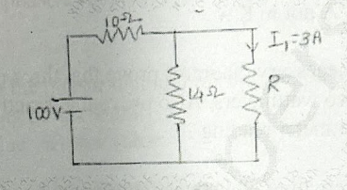
12. Find the value of R in the following circuit.

13. Find the current through 4ohm resistor by source transformation in the following circuit.
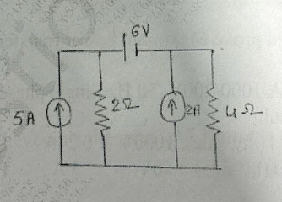

14. Convert the given voltage source to current source. Give the steps of conversion.
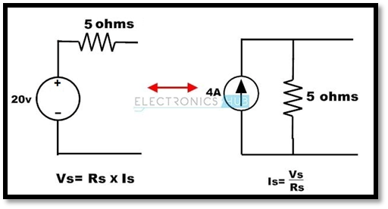
15. Give the steps to find current in a branch using Nodal analysis. Calculate voltage VA using Nodal analysis.


